Message to Hash Value 🡪 Possible  
Hash Value to Message 🡪 Not Possible

So they are known as One Way Function

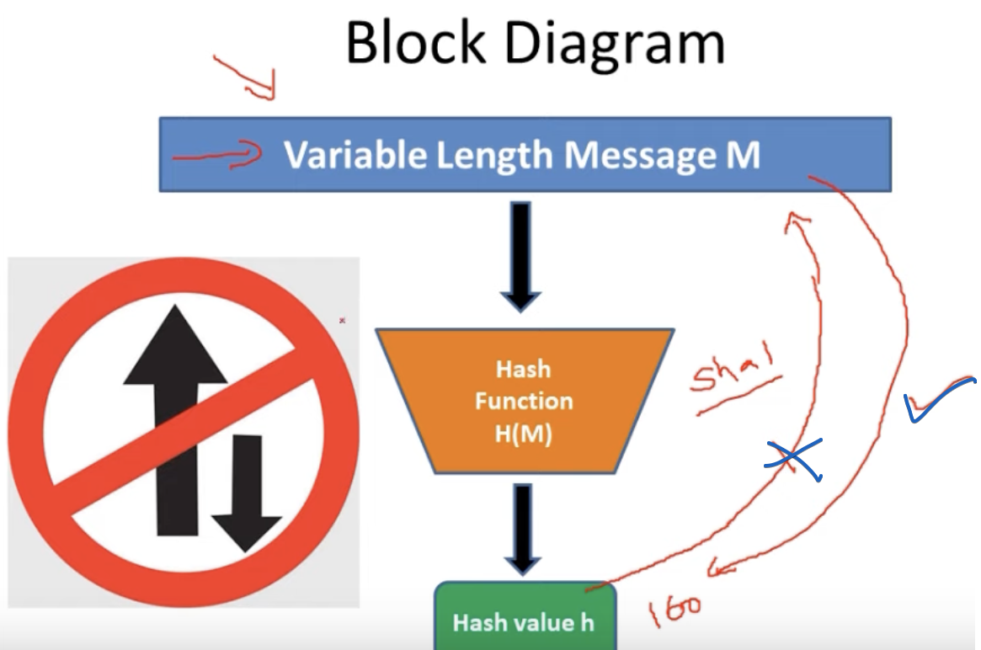



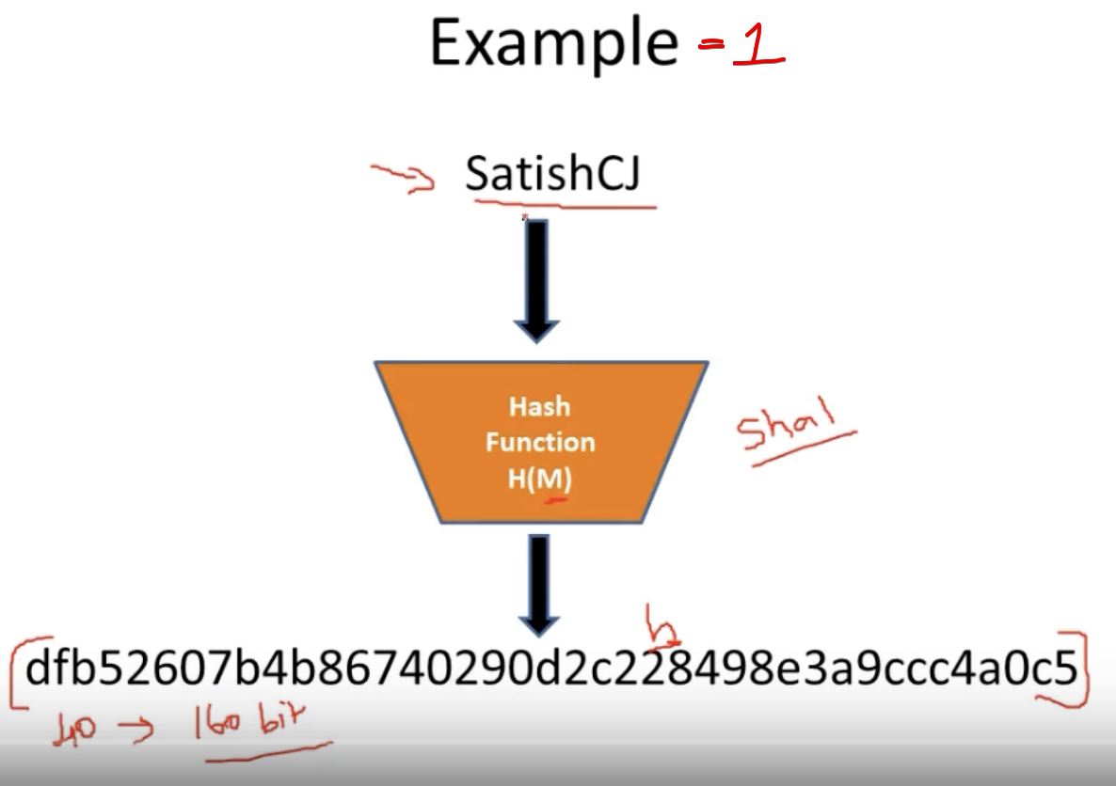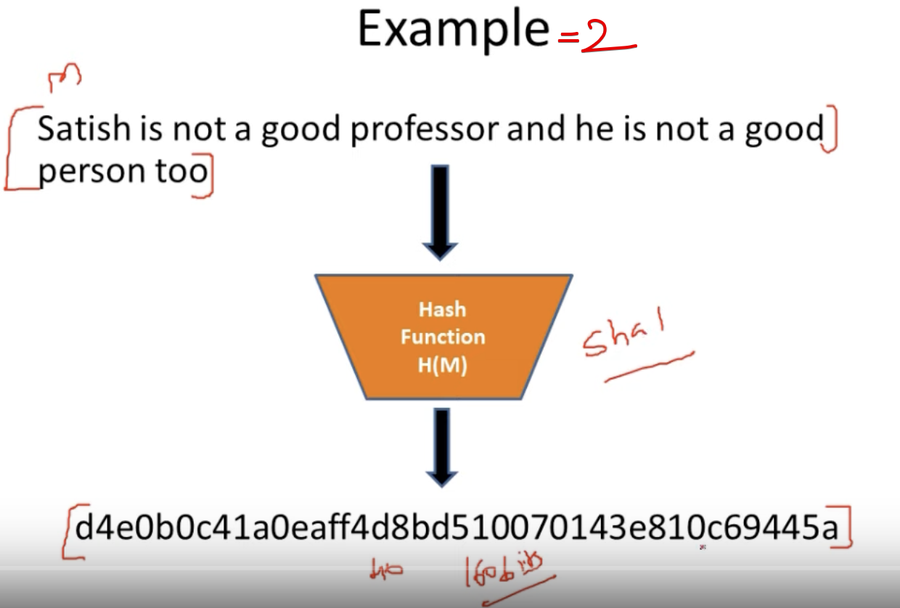

No matter the message, the output will be fixed 🡪 40 hexadecimal characters(160 bits) for a particular hash function “sha1”.

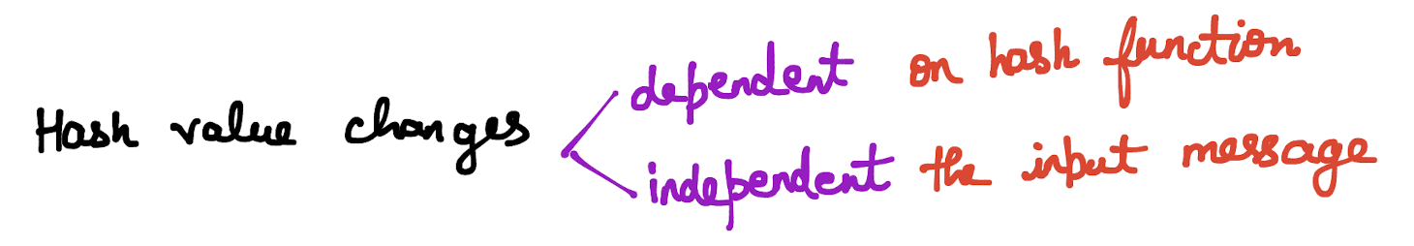

Using the hash value, not able to traverse back to the original message unlike encryption and decryption.

# **Properties of a good Hash function**

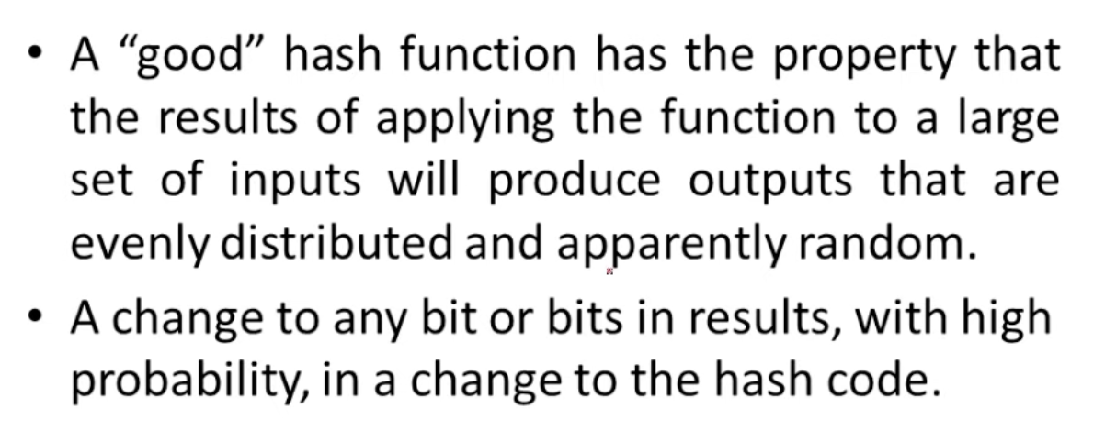

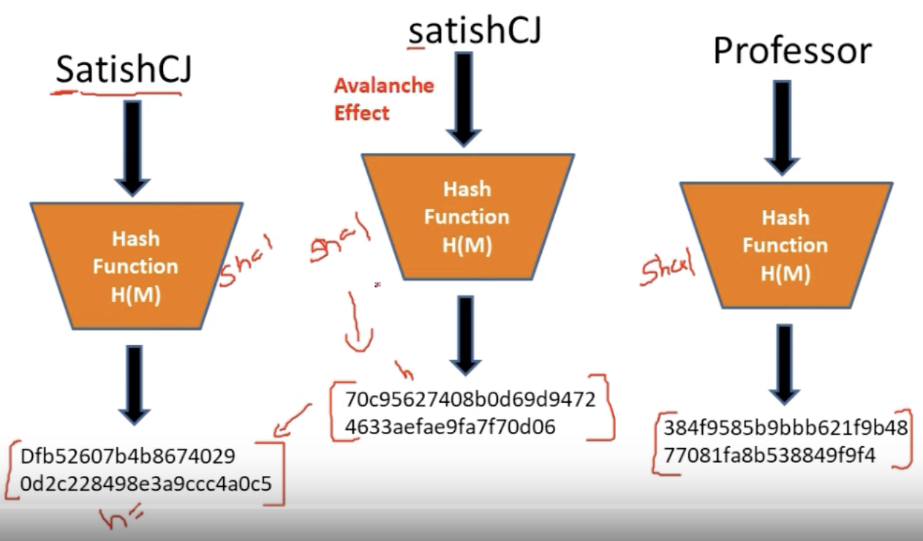

Even a change in a single bit 🡪 hash value entirely changes.

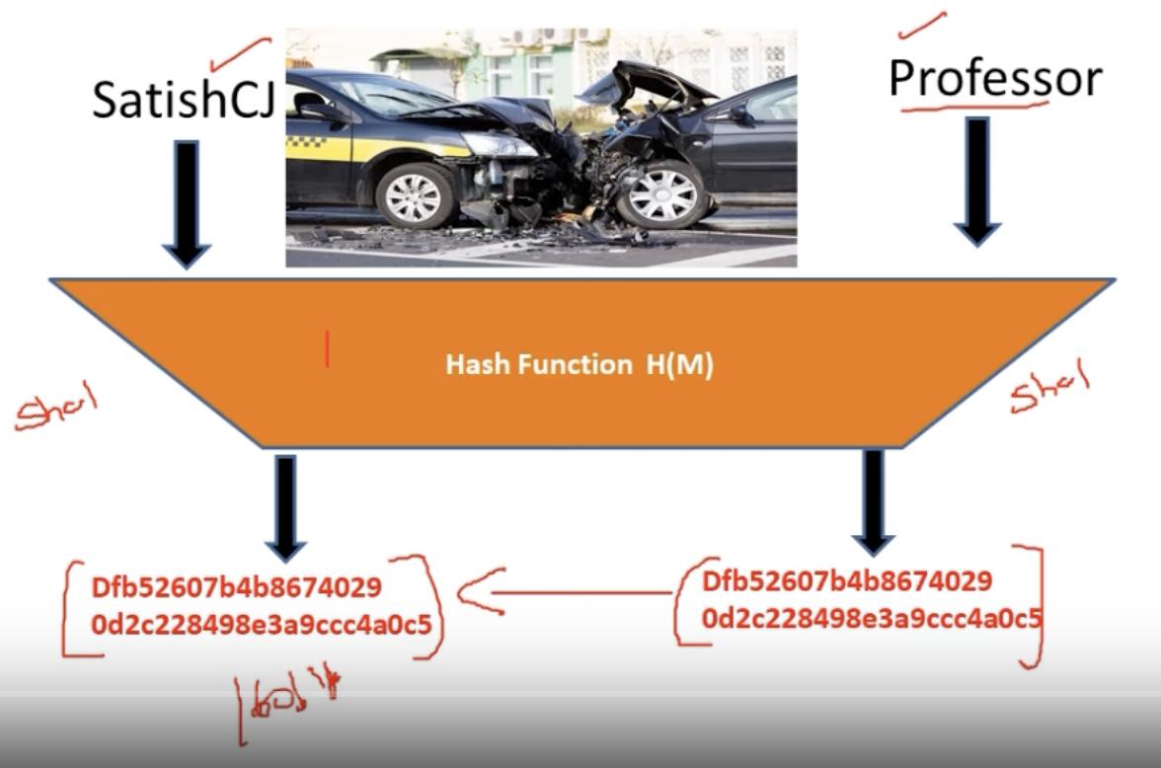

There should be no same hash value for 2 different message. If so, then collision.  
A good hash function should be collision resistant.

# **Cryptographic Hash Functions**

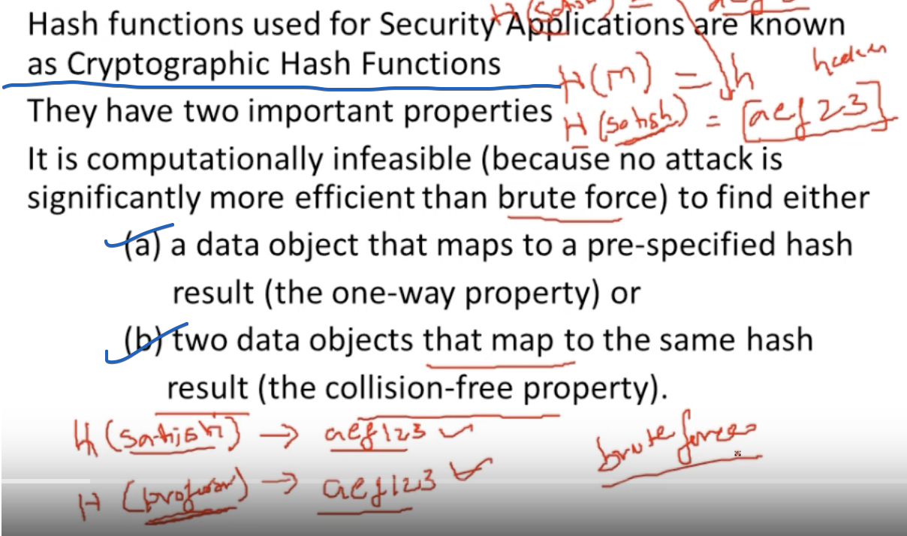

Both the Hash(message) produces a same result, Hacker will found this only in Brute Force Approach.



# **Applications of Hash Functions in Cryptography**

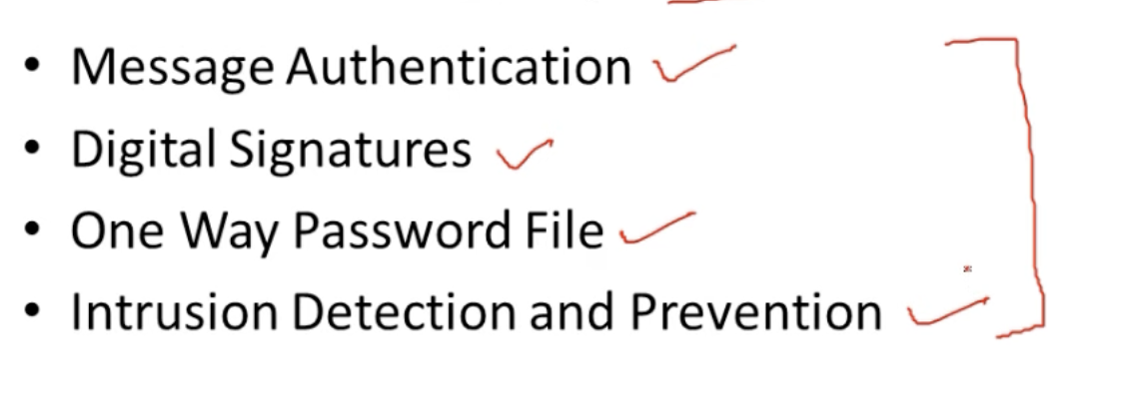

## **Message Authentication**

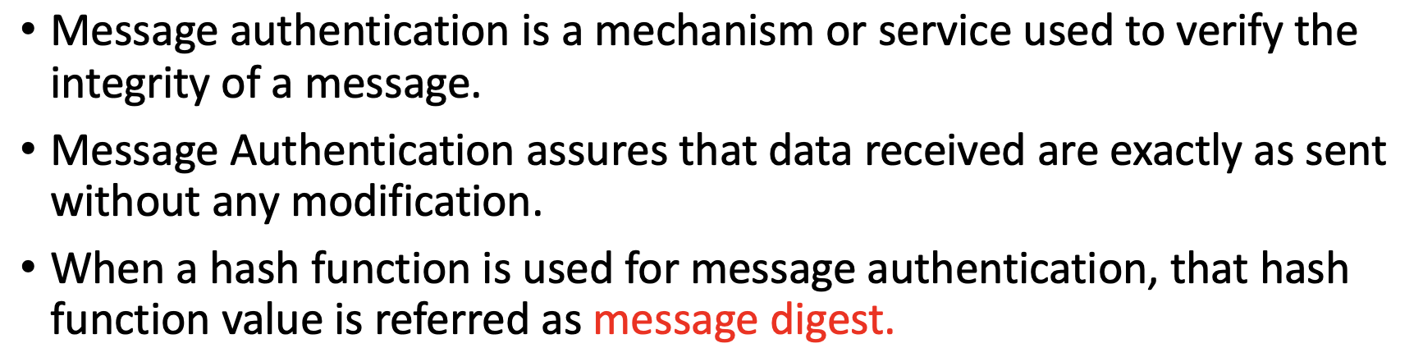

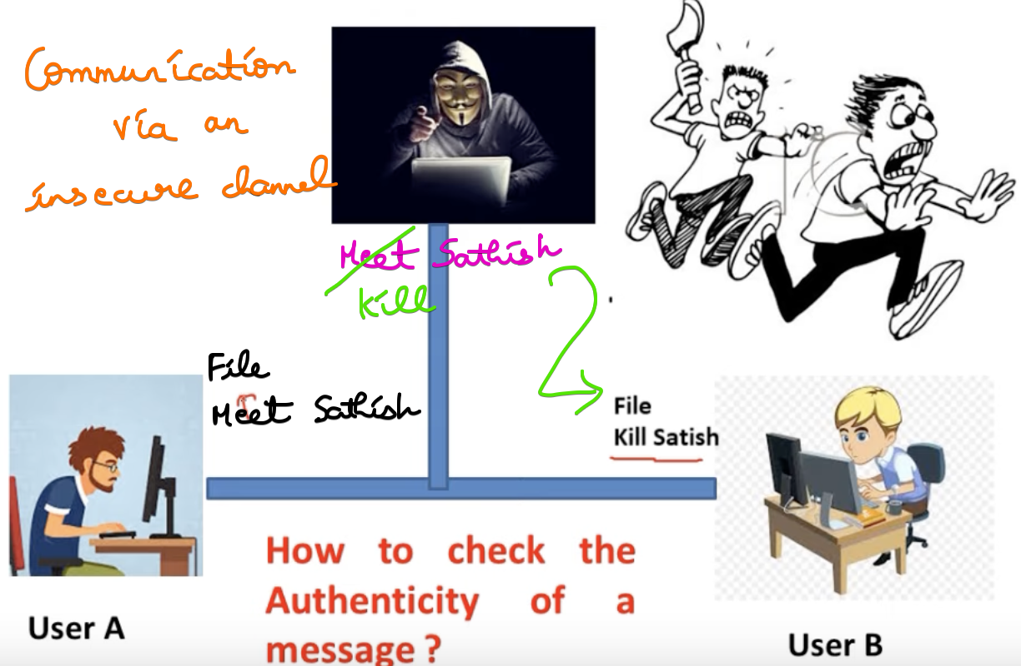

The hacker modifies the message.

User-B thinks that User-A sent the message “Kill Satish”

### **Both message and hash code encrypted**

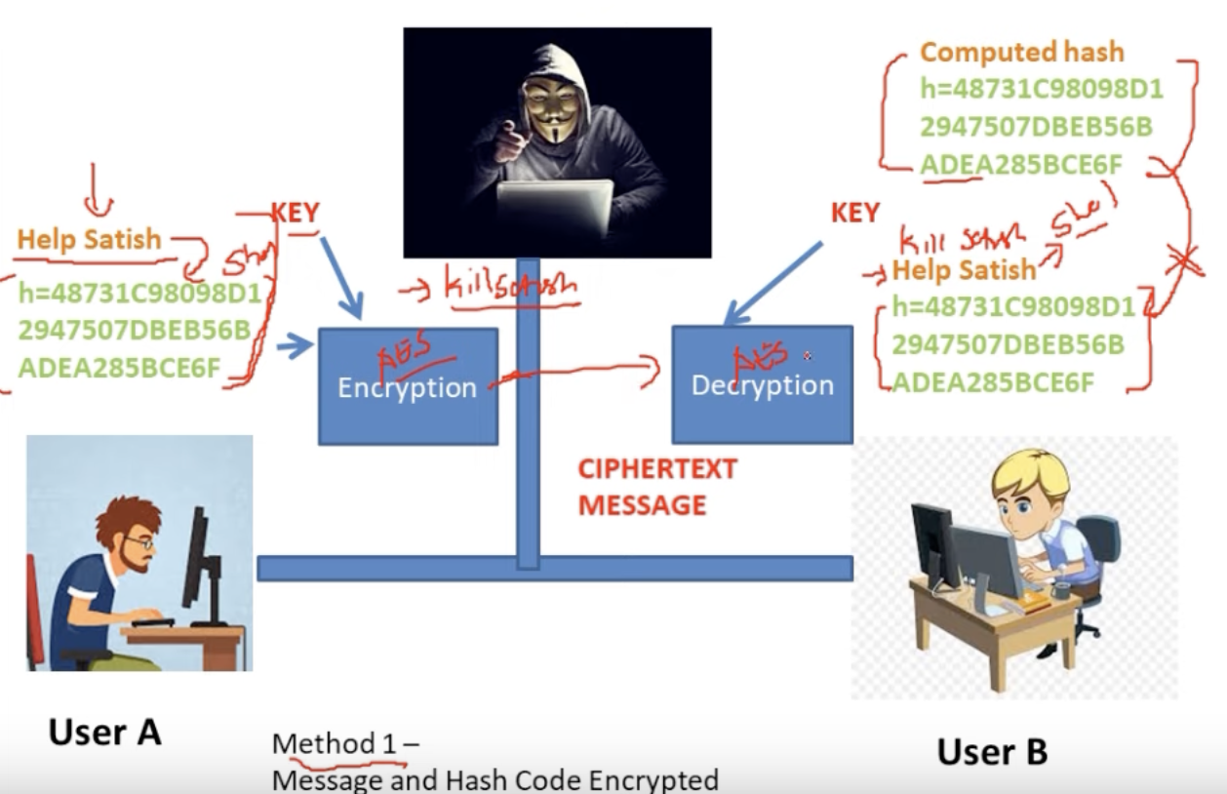

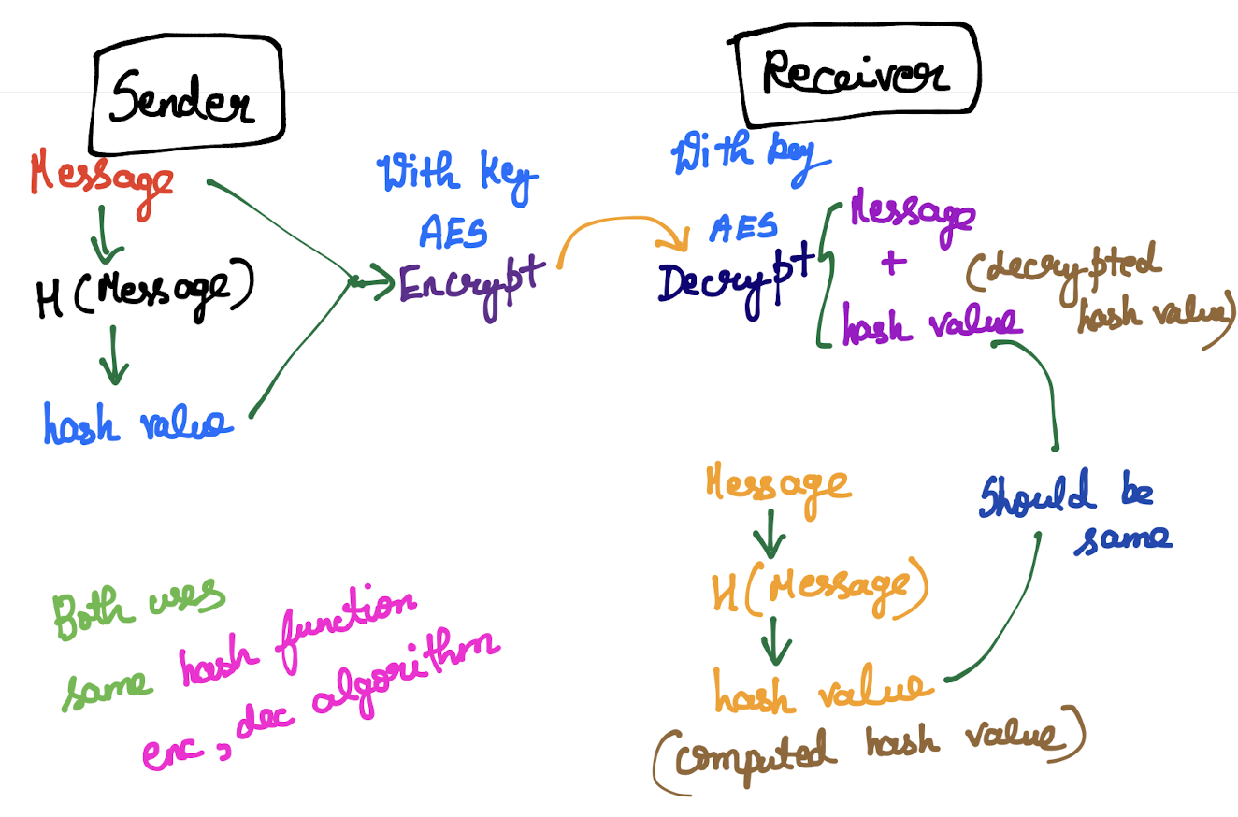

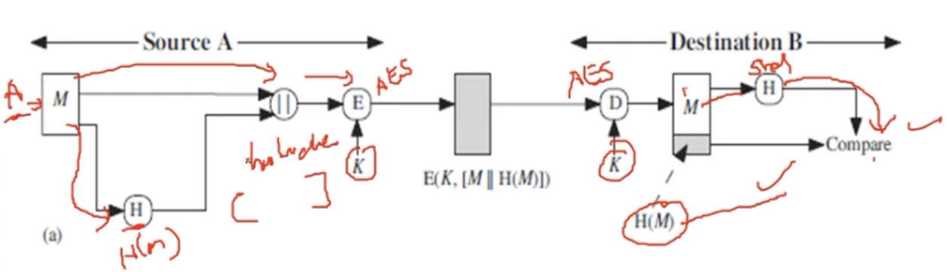

Message is highly confidential. 🡪 So only encrypting

### **Only hash code encrypted**

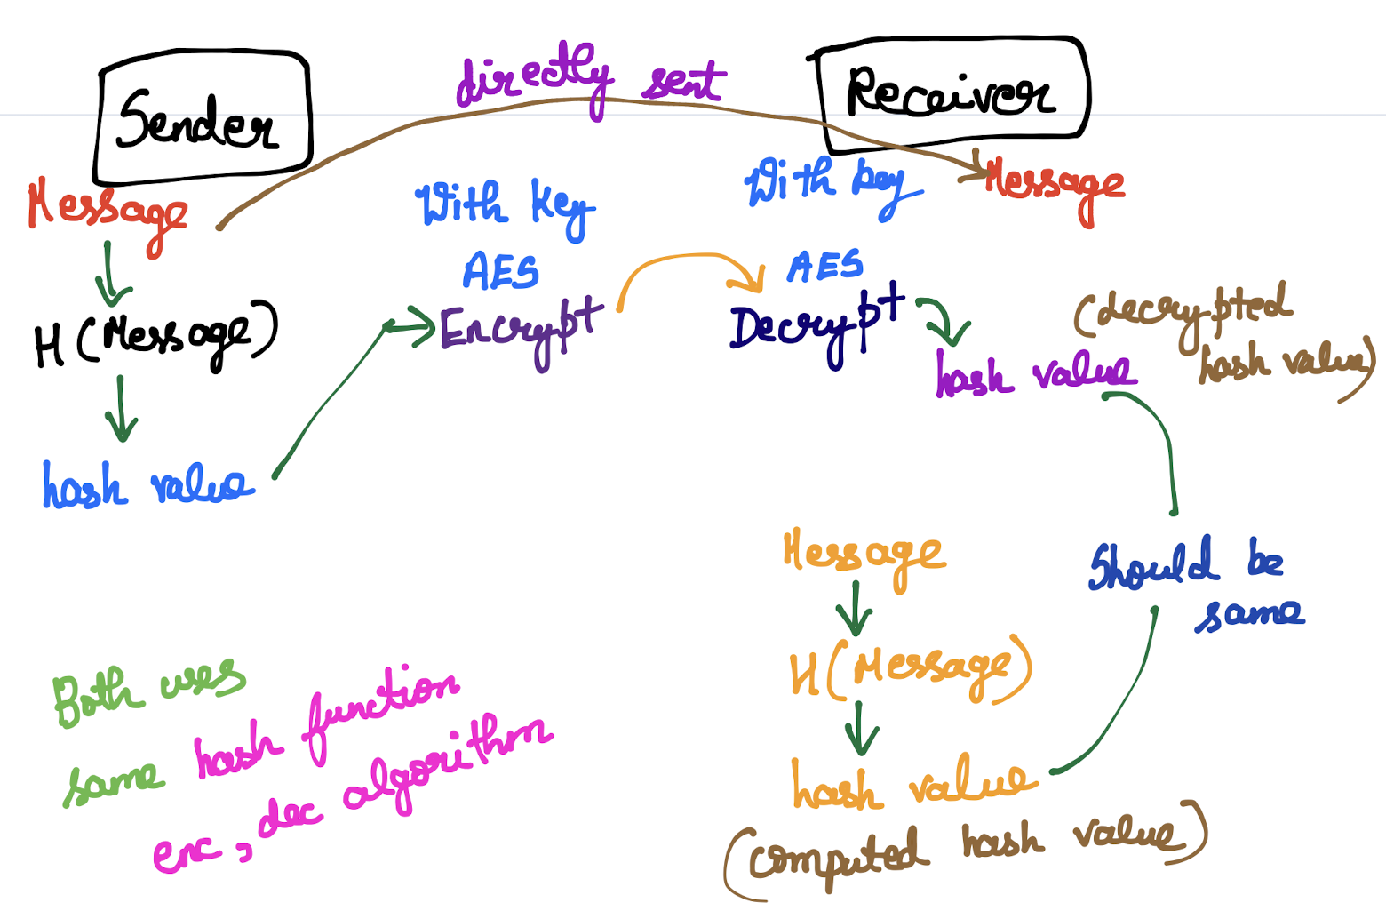

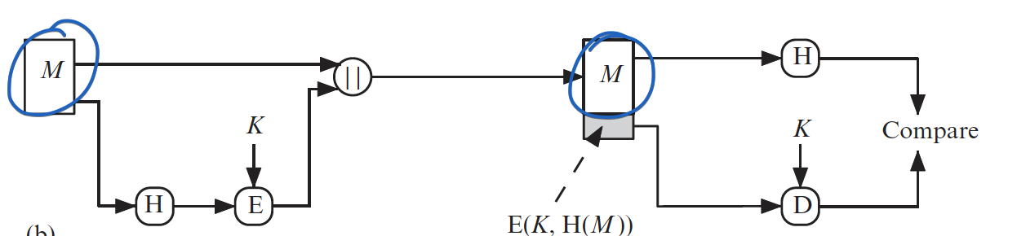

Message is sent directly  
Hash Code is encrypted and decrypted.

Message is Not confidential. 🡪 So only just sending.

Only Message Authentication is only important.

### **Sharing a Secret Value for Message Authentication**

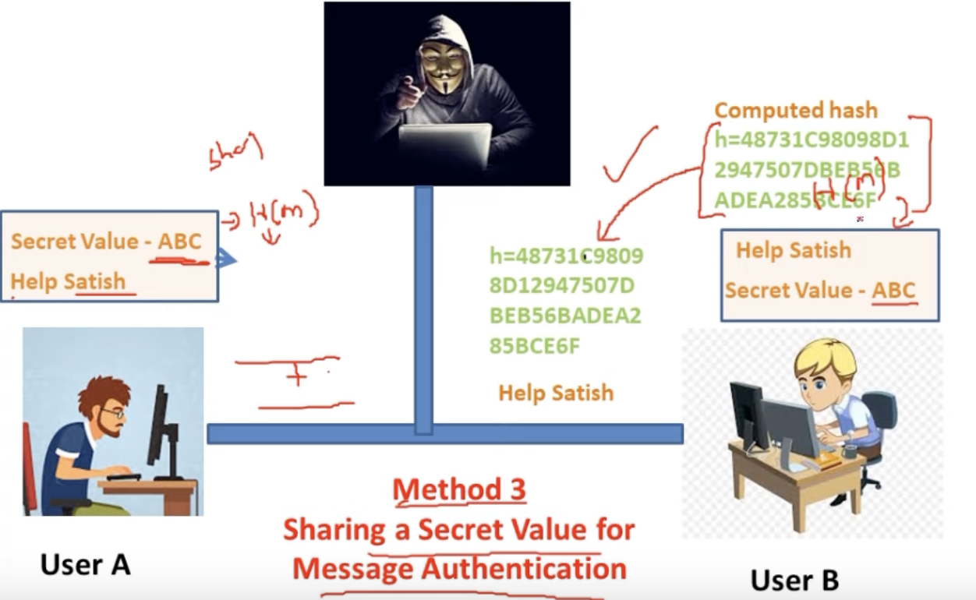

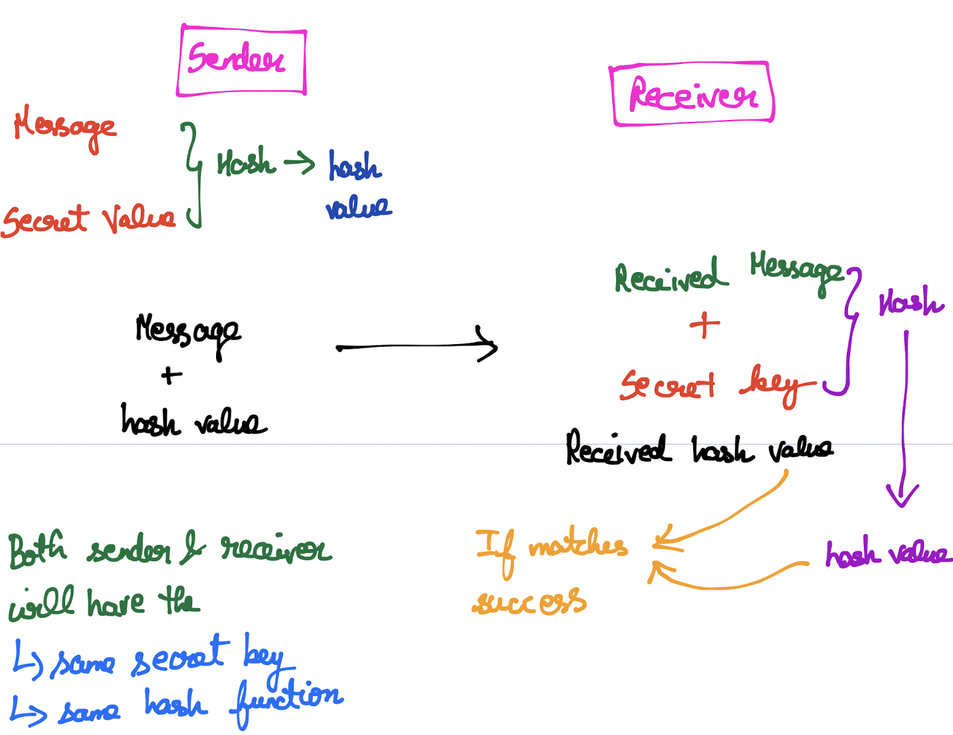

If the hacker modifies the message also, At the receiver side computed hash and received hash do not match.

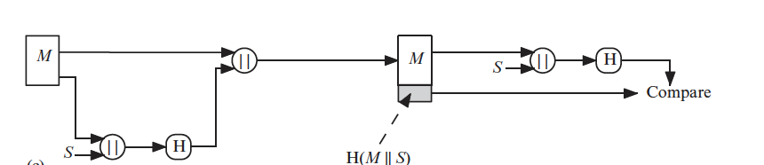

Message is highly confidential. 🡪 So only using Secret key.

### **Adding some more confidentiality**

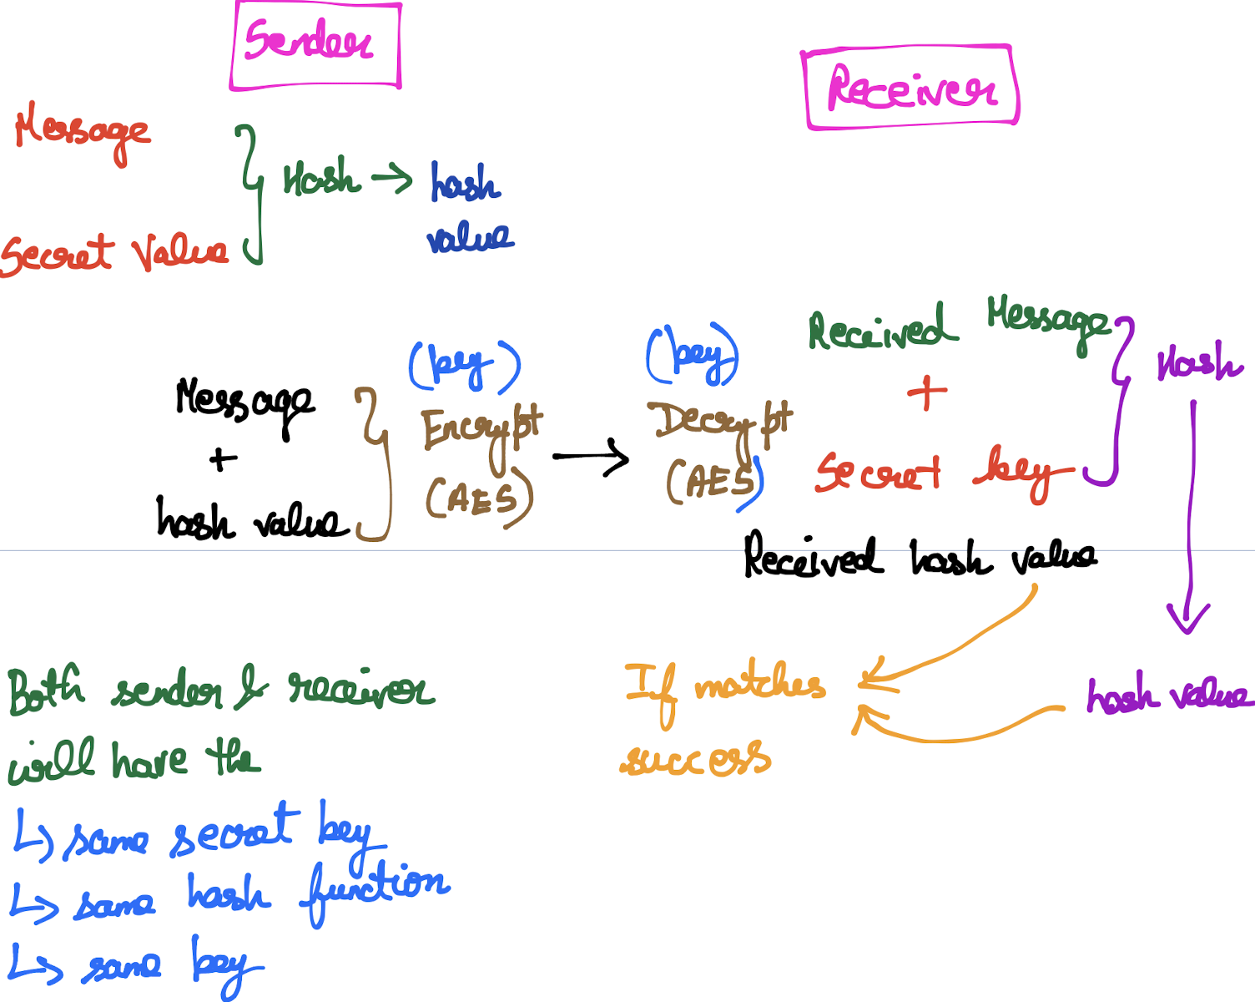

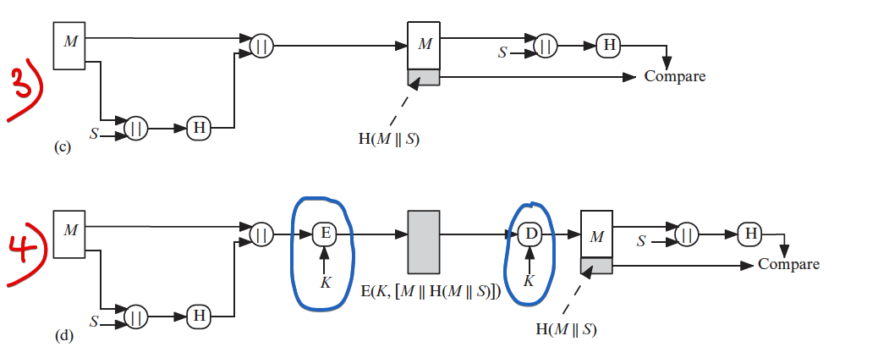

## **Digital Signature**

User-A sends a message to User-B.  
How User-B knows, User-A only sent that particular message.

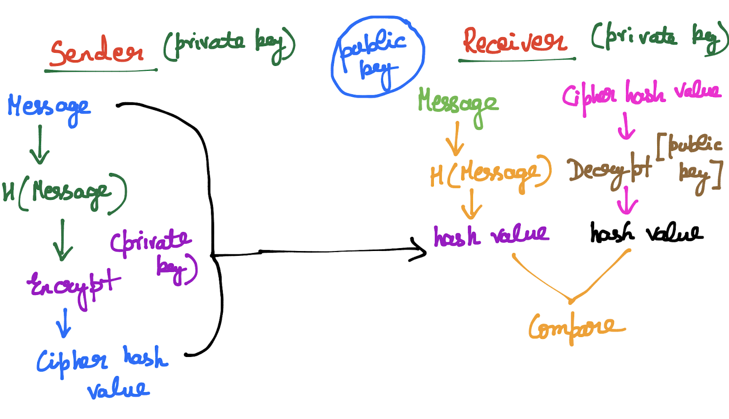  
Here the message is sent as a normal plain text.  
Only the hash code is decrypted and sent.

We can decrypt the “cipher hash value” using the public key, only when that “hash value” is encrypted by the Sender.  
This clearly indicates that the user who is in-tended to send the message, only we received.

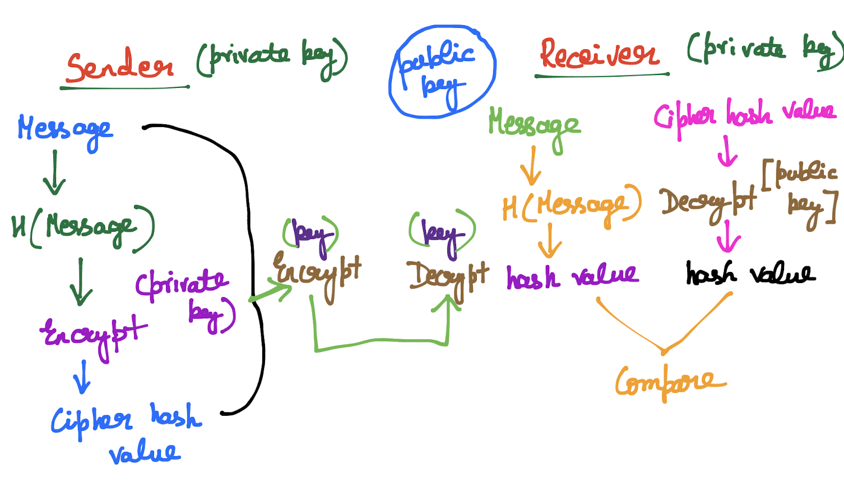

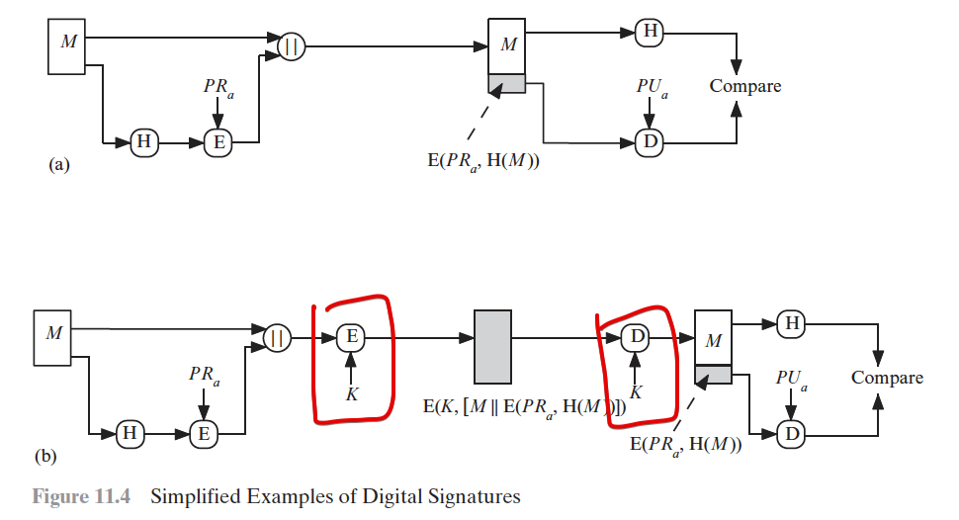

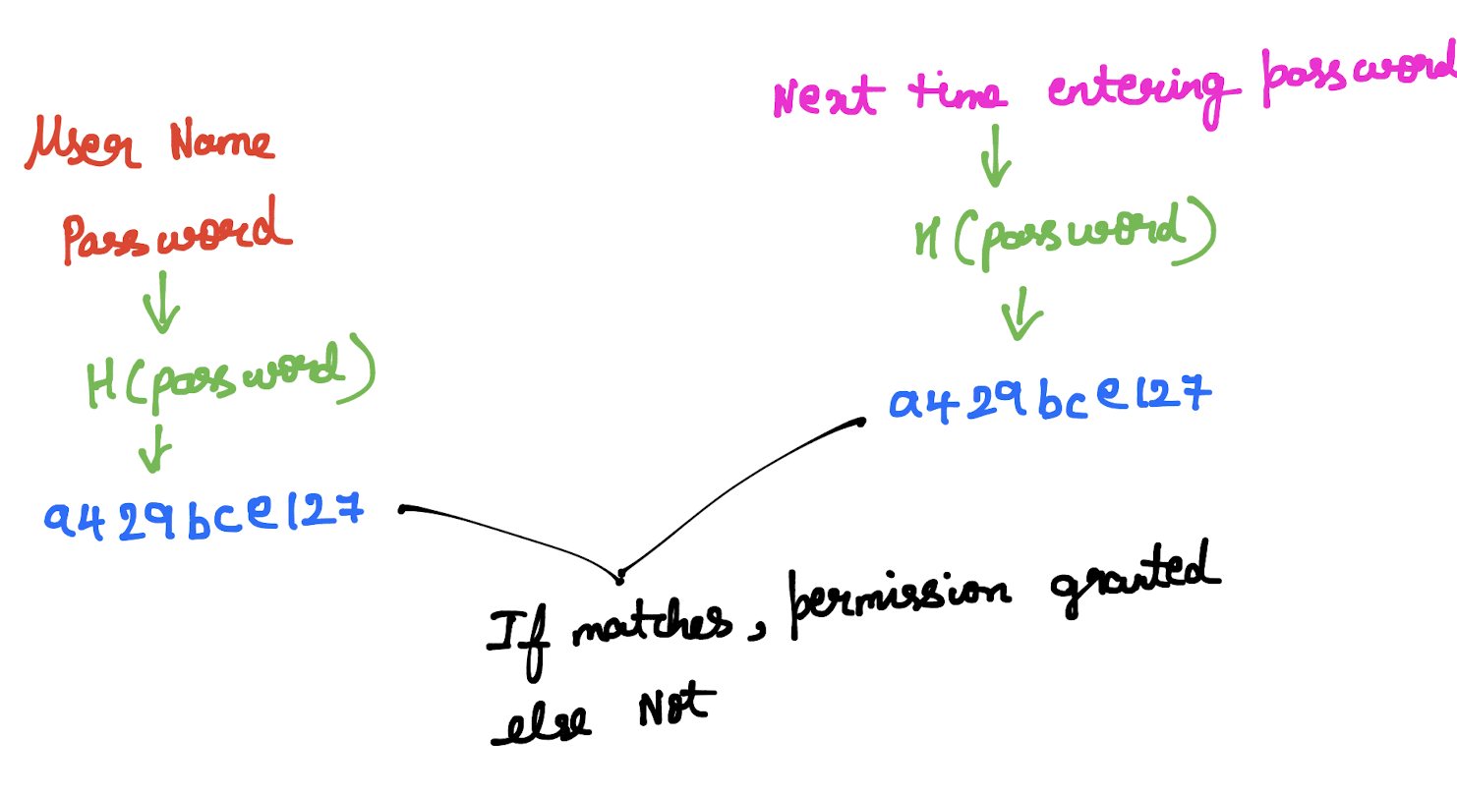

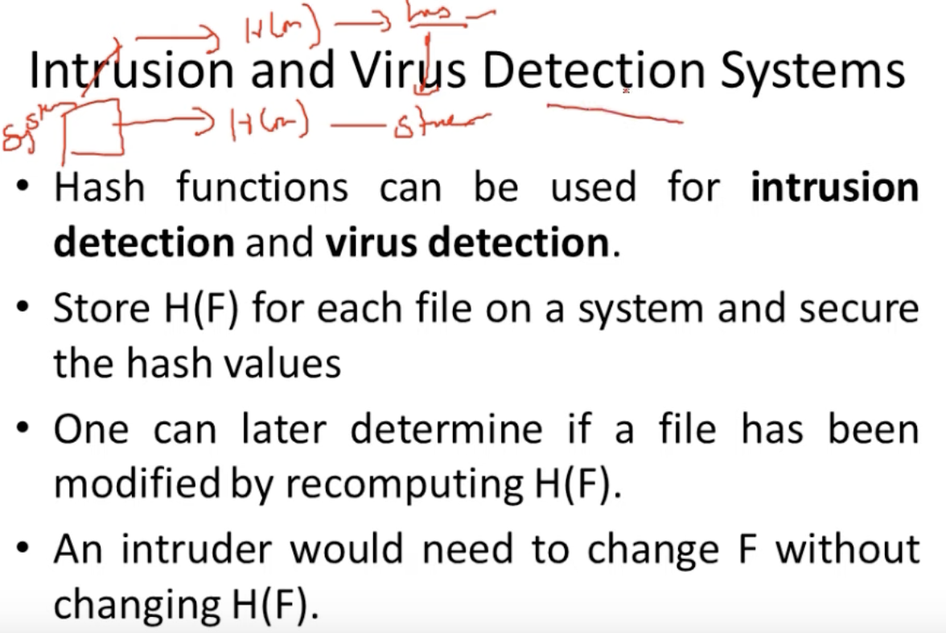

# **Security Requirements for Cryptographic Hash Functions**

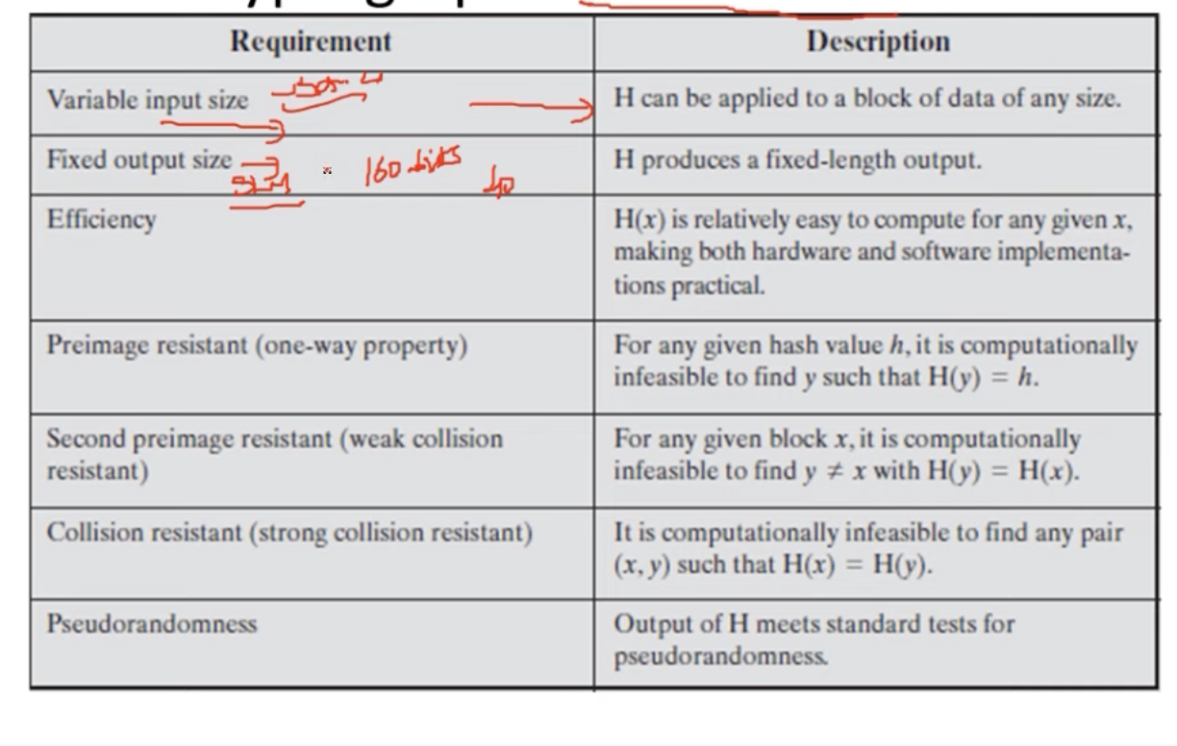

## **First Pre-image Resistant**

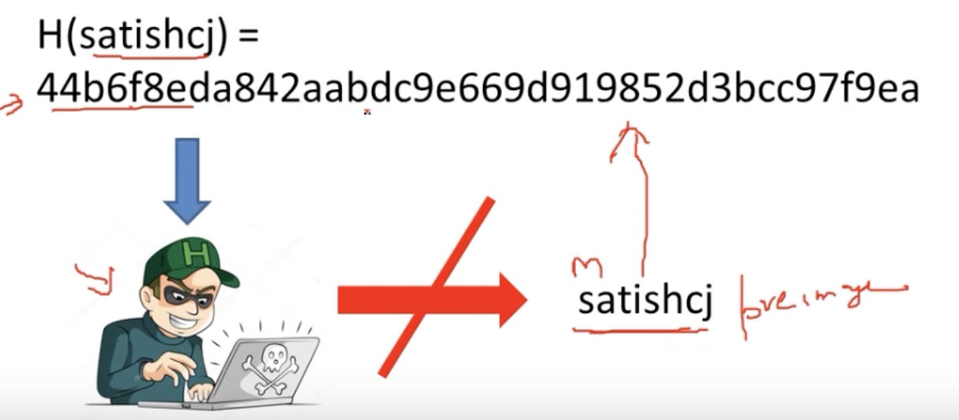

Even-though the hacker knows the hash value, he cannot able to traverse back and find the password.

## **Second Pre-image Resistant**

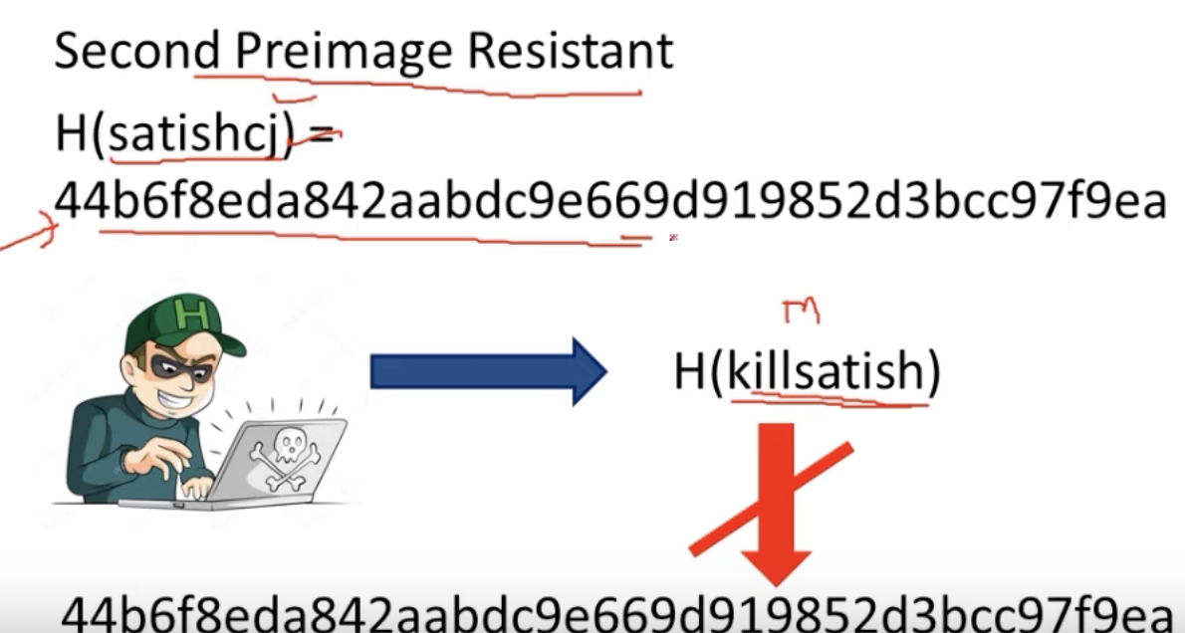

If Hacker knows the message and hash value.  
And tries to modify the message, then the hash value differs.

Hence two different messages will not have a same hash-value.

If so, hacker modifies the message and sends, the hash value differs. So the act of an hacker pretending as a sender will be found very easily.